Lead Climbing Clinic

Interested in Lead Climbing at the HPER Climbing Wall? Then this clinic is perfect for you!

When: 7:00pm – 10pm
September 12th
October 10nd
November 14th

Location: Climbing Wall, HPER Gym 1
Trip registration and payment are due the day prior to the clinic.

Cost: $10 student/$20 member/$30 non-member

Description:
This clinic is designed to educate participants on the practices and policies required for lead climbing at our indoor climbing wall, while also creating a general foundation climbers can take with them when they leave the clinic. Topics covered in the clinic are proper communication, lead belaying, climbing and clipping techniques, falling, rope management, and risk mitigation. After completion of the course you will need to pass the lead climbing and belaying test in order to lead climb at the wall.

Prerequisites:
Participants must have successfully completed a GRIGRI belay assessment at the HPER climbing wall prior to registering for this course.

Participants are allowed to provide their own harnesses, climbing shoes, and chalk. The UREC Outdoors provides these items if participants do not have their own. All hardware to be used must be that provided by UREC Outdoors.

Phone: 479-575-CAMP
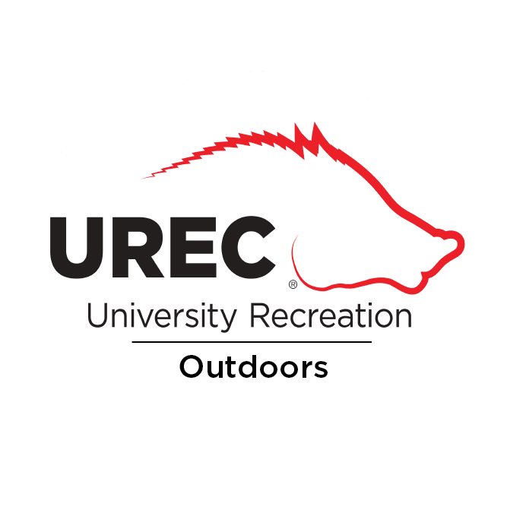
Email: camp@uark.edu
Registration: https://urecmembers.uark.edu/ or HPER 102

